Problème avec la méthode de Lehmer pour la génération d’un entier sur 128 bits.  
Durant 30 min j’ai identifier le problème. Etant sur Visual Code, le compilateur ne permet pas de compiler ce type.   
J’ai observé qu’une compilation était possible qu’à partir de x86-64 gcc 6.1

**Hilbert transform**: A number of methods have been proposed for computing the Wigner distribution without resorting to this increase in sampling rate. The most widely used of these methods are 1) the application of the Hilbert transform to obtain an analytic signal, and 2) time domain interpolation by a factor of two.

No universal test or battery of tests can guarantee, when passed, that a given generator is fully reliable for all kinds of simulations. But even if statistical tests can never prove that an RNG is foolproof, they can certainly improve our confidence in it. One can rightly argue that no RNG can pass every conceivable statistical test. The difference between the good and bad RNGs, in a nutshell, is that the bad ones fail very simple tests whereas the good ones fail only very complicated tests that are hard to figure out or impractical to run.

Hop set: It is the number of different frequencies used by the system.  
Dwell time: It is defined as the length of time that the system spent on one frequency for transmission.  
Hop rate: It is the rate at which the system changes from one frequency to another.

**MFSK**  
"Multiple Frequency-Shift Keying". Nous avons choisi la MFSK car, elle est souvent utilisée dans les sauts traditionnels comme par exemple le Bluetooth, et offre un bon taux d’erreur binaire dans un environnement de bruit Gaussien

**BER/SNR**

FHSS utilize pour le Bluetooth 802.15.1. Dans le Bluetooth, la bande est subdivisée en 79 canaux distincts de 1MHz chacun.

En termes de puissance rayonnée, tous les systèmes sans fil qui fonctionnent dans la bande 2,4 GHz (bande UHF bluetooth) sont limités à une puissance radio maximale de 100 mW (+ 20 dBm). En plus de cela, d'autres règles sont applicables en fonction de comment le spectre est utilisé. La puissance rayonnée des systèmes qui utilisent la technique d’étalement de spectre par saut de fréquence (FHSS : Frequency Hopping Spread Spectrum) est limitée à 100 mW par 100 kHz de bande passante.

Expression des symboles pour une modulation M-FSK :  
𝑣𝐹𝑆𝐾(𝑡) = 𝐴 𝑐𝑜𝑠[2𝜋(𝑓𝑐 + 𝑓𝑘)𝑡] ; 𝑎𝑣𝑒𝑐 𝑣𝐹𝑆𝐾 𝑙𝑎 𝑓𝑜𝑟𝑚𝑒 𝑑′𝑜𝑛𝑑𝑒, 𝑘 ∈ {0, … , 𝑀 − 1} 𝑒𝑡   
𝑓𝑘 = [(2𝑘 − (𝑀 − 1)) ∆𝑓] 𝑎𝑣𝑒𝑐 ∆𝑓 𝑙𝑎 𝑑𝑒𝑣𝑖𝑎𝑡𝑖𝑜𝑛 𝑒𝑛𝑓𝑟é𝑞𝑢𝑒𝑛𝑐�

FHSS systems operate with SNR (Signal to Noise Ratio) of about 18 dB.  
Assuming that the transmitted symbols pass through a linear white Gaussian channel, the received discrete signal will be r(n) = sk(n) + w(n) (3.15) w(n) is a discrete sample function of a white Gaussian noise process c(t) with a zero mean and (σ_w)^2 variance and s_k(n) the sampled version of the signal

<http://eprints.whiterose.ac.uk/136718/1/NAFOSTED%20Conference%202018.pdf>**Bruit blanc Gaussien**

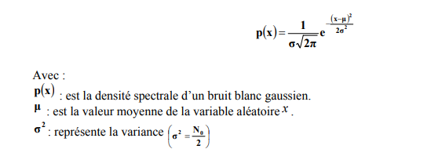Le modèle du canal AWGN est composé d’un bruit blanc Gaussien ajouté dans le médium à l’onde modulée. Un bruit blanc Gaussien est un processus aléatoire stationnaire puisqu’il est indépendant du signal transmis. La spécificité d’un bruit blanc réside dans l’uniformité de sa densité spectrale de puissance qui vaut No sur toute la bande de fréquences. Du fait de sa largeur de bande théoriquement infinie, il est difficile d’exprimer le bruit blanc, c’est pourquoi l’on suppose que le bruit sommé au signal d’entrée du récepteur a été filtré par un filtre idéal, de largeur de bande très grande devant la bande utile [47]. Le bruit blanc peut être rendu Gaussien par une distribution gaussienne. Ainsi, le bruit doit suivre la loi normale, ou loi de Gauss, régie par la densité spectrale suivante :

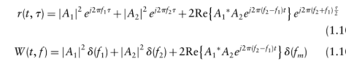**Wigner-ville distribution**

The third term in this WVD is the cross-term. It should be noted that this crow-term between the two auto-terms and it oscillates. The magnitude of the cross-term is twice that of the auto-terms (assuming A, = Axl The cross-term oscillates more rapidly, further apart the auto-terms.   
**Cross-terms** oscillate   
**Auto-terms** commonly have slowly varying amplitudes.

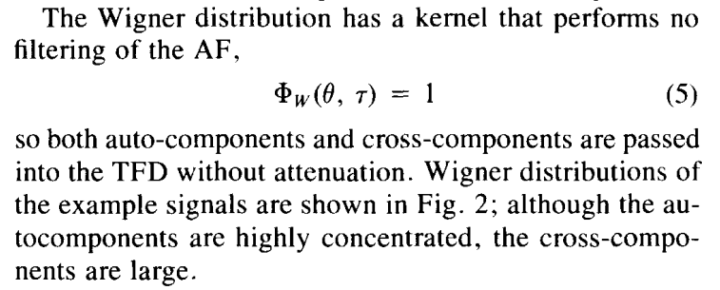

**Pour limiter le compute ressource de la détection à partir de la tfd, il faut une high resolution tdf.**

**IF décrit la variation en fréquence avec le temps**

**COMPLEXITY**

[**https://ieeexplore.ieee.org/document/4258315**](https://ieeexplore.ieee.org/document/4258315)

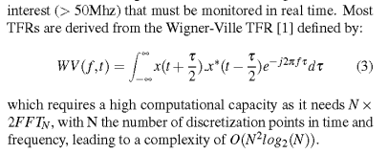

**Gaussian kernel:  
FHSS signals could be very closely frequency spaced, or there could be other signals resented in the ISM frequency band. In the case of the multicomponent signals with closely spaced components, the decomposition procedure may fail if the components are not properly spaced (if there are overlapping or cross-terms). In order to overcome this problem, decomposition is combined with distributions from the Cohen class. It has been shown that, by properly adapted kernel shape, the Cohen class TFDs based n Gaussian kernel can provide reduction of the cross-terms, providing at the same time the best concentrated components in the TF plane. The results are verified by measuring the MSE of IF estimation for signal components.**

Generally, the evaluation indexes for ideal TFR include the following properties: higher clarity to make it easier to be analyzed and interpreted, less cross-term to avoid confusing real components from artifacts or noise, many desirable mathematical properties to ensure such methods benefit real-life application, and lower computational complexity for implementations

signal-dependent kernel functions, which are attained by the separation property of auto-terms and cross-terms in the ambiguity domain; that is, the auto-terms concentrate at the origin, whereas the cross-terms lie away from the origin.22–

If our signal of interest was composed entirely of transients or entirely of sinusoidal terms we would be able to choose a short window in the former case or a narrow filter in the latter case, and the STFT would prove to be adequate for our analysis. In practice, however, many signals have both long duration sinusoidal and transient components. For these types of signals the STFT is often not the right tool for adequate analysis. What is needed for these types of signals is a multiresolution analysis, one type of which may be obtained with wavelets

**Off-line implementation** mean that the algorithm is not on the simulator before implementing a on the real system. On the other hand, in an **on-line implementation**, the algorithm does not use a simulator, but runs on real-time basis in the real system.

**AOK**

The signal-dependent TFR with radially Gaussian kernel described in Section I1 has many attractive qualities, but it is based on a block algorithm that designs only one kernel for the entire signal. For signals with characteristics that change over time, for real-time, on-line operation or for very long signals, an adaptive signal-dependent TFR is more desirable.

The signal-dependent representation performs much better than the fixed-kernel methods. however, it is limited to processing relatively short signals in an off-line fashion. Moreover, this block-oriented technique designs only one kernel for the entire signal, thus forcing compromises in the kernel design for signals with multiple components.

Pour les signaux dont les caractéristiques changent avec le temps, pour un fonctionnement en ligne en temps réel ou pour des signaux très longs, une TFR adaptative dépendante du signal est plus souhaitable. Un algorithme adaptatif modifie le noyau à chaque fois (temps) pour obtenir une performance locale optimale, ce qui permet de mieux suivre les changements dans un signal.

The signal-dependent representation performs much better than the fixed-kernel methods in Fig. 1; however, it is limited to processing relatively short signals in an off-line fashion

Adaptation of the kemel over time is beneficial because it permits the kernel to match the local signal characteristics

The AF is utilized in the optimization formulation because of its important separation property: The auto and crosscomponents separate somewhat in the AF plane, with the autocomponents lying centered at the origin and the crosscomponents lying away from the origin

The constraints and performance index are motivated by a desire to suppress crosscomponents and to pass autocomponents with as little distortion as possible

**Tranformée de Hilbert Huang :   
Pourquoi ne pas le choisir :** Although the empirical mode decomposition (EMD) is effective in monocomponent decomposition, it has some shortcomings, such as lack of mathematic formulation, susceptibility to mode mixing under singularities, instability under noise interferences, over/under fitting due to cubic spline interpolation.

**FHSS**

The FHSS technique has found its largest application area in Bluetooth. Moreover it is used mostly in the 902–928 MHz ISM band but not very often in the 2400–2483.5 MHz worldwide available ISM band

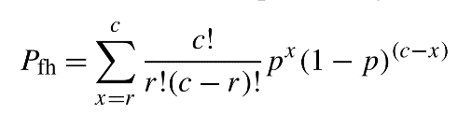The FHSS system has an intrinsic capability to cope against strong narrowband interferers and fading by increasing its hopping rate. Supposing that N hopping channels are available and J out of N are jammed because of strong fading condition or from a large interferer, then if a single bit is transmitted on different channels and a majority decision criteria is used, the probability of error for a given bit is:

where p = J/N, c is the number of bins in which the same bit is sent and r is the number of errors necessary to cause a bit error.1 In Fig. 2.5 the probability of error versus the initial error probability is shown for different hopping rates. By varying the hopping rate it is possible to decrease by an order of magnitude the BER without increasing the transmitted signal power.  
(Architectures and Synthesizers for Ultra-low Power Fast Frequency-Hopping WSN Radios)

Polyphase filters bank